[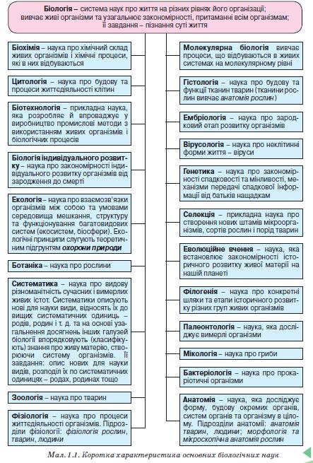](http://school.xvatit.com/index.php?title=%D0%A4%D0%B0%D0%B9%D0%BB:B1.jpg)